SIEM WAZUH LAB
Overview
This lab documents the deployment of Wazuh, a free and open-source Security Information and Event Management (SIEM) and Extended Detection and Response (XDR) platform, in a home lab environment. The objective was to build a working SIEM setup capable of collecting, analyzing, and alerting on security-relevant events from an endpoint, and to specifically demonstrate File Integrity Monitoring (FIM), the ability to detect and log real-time file creation, modification, and deletion on a monitored system.
Lab Architecture
Component | Host | Role
Wazuh Manager | Ubuntu Server 22.04 (VMware VM) | Collects, analyzes, and stores data from connected agents; hosts the indexer and web dashboard
Wazuh Agent | Windows 11 (host machine) | Sends system logs and file-integrity events to the Wazuh manager

- Ubuntu installation:
At first I installed the ubuntu virtual machine on the Vmware.
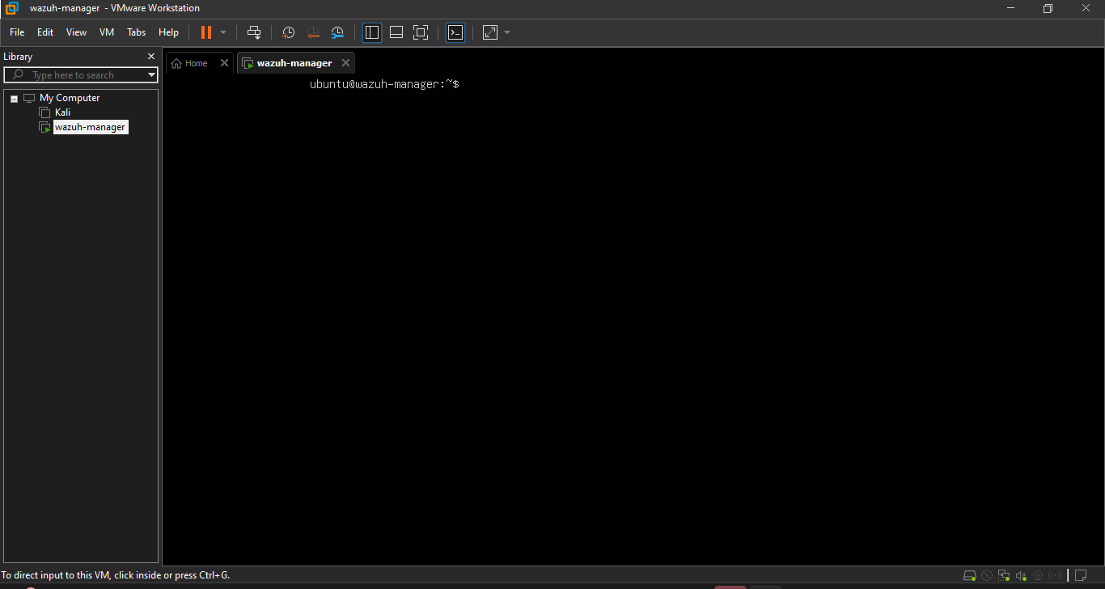
Figure 1 Ubuntu server
- Check the network
After installation I run the ip a command to know the ip address of my ubuntu vm machine.
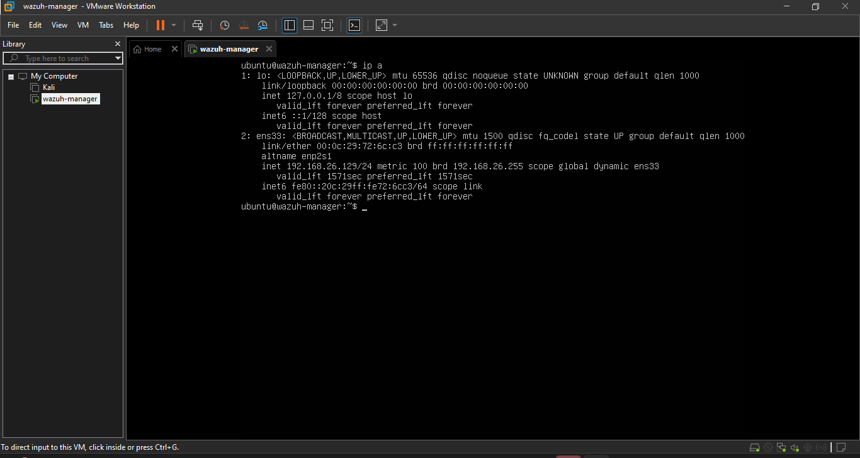
Figure 2 Checking ip address

Then I opened the powershell in windows (your host machine) and run
ssh <your-username>@your ip address

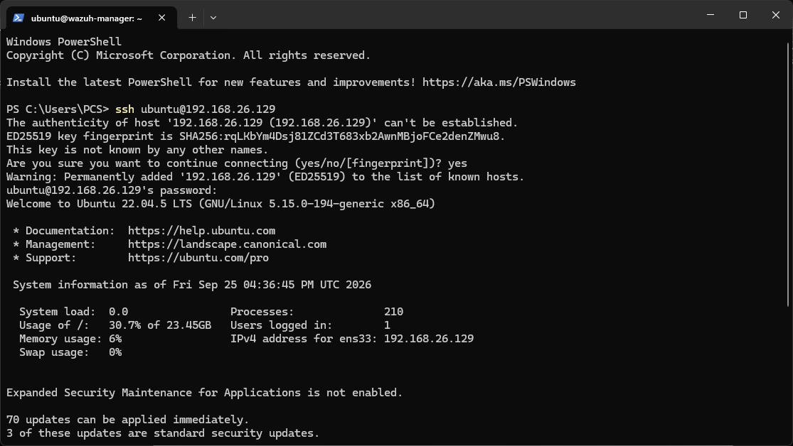
Figure 3 windows powershell
Now I typed commands in windows powershell for ubuntu
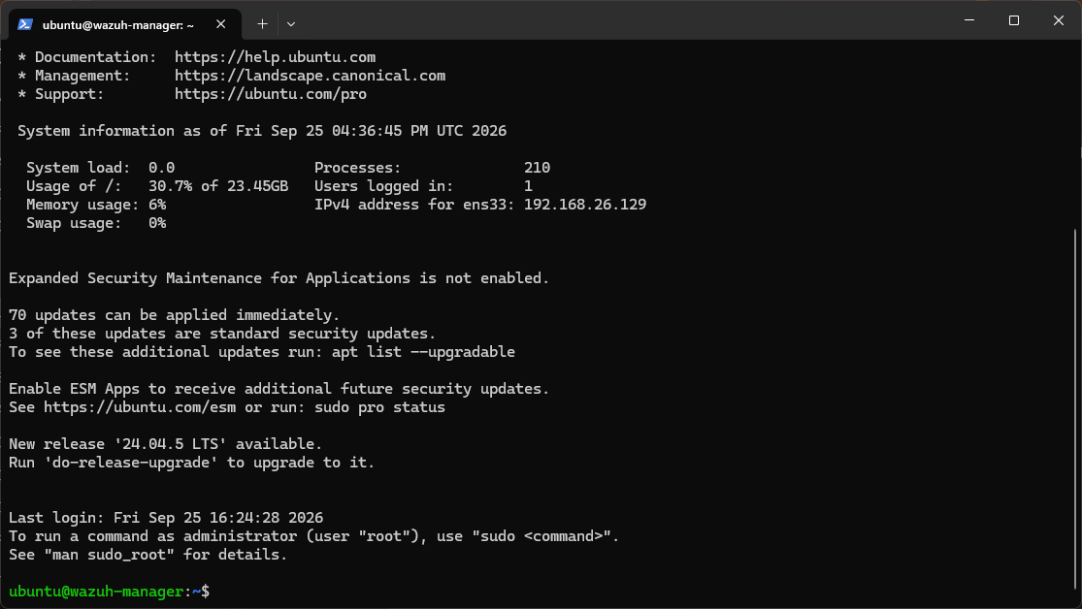
Figure 4ubuntu server on windows powershell using ssh
To use the full Storage I used the following commands:
sudo lvextend -r -l +100%FREE /dev/ubuntu-vg/ubuntu-lv

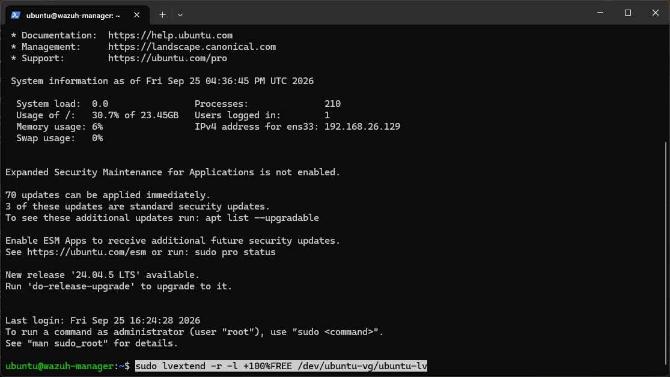
Figure 5 Command to use full storage
Then I confirmed the installation with the following command:
df -h /
Figure 6 confirming the following command worked or not

Then I upgraded and updated the system
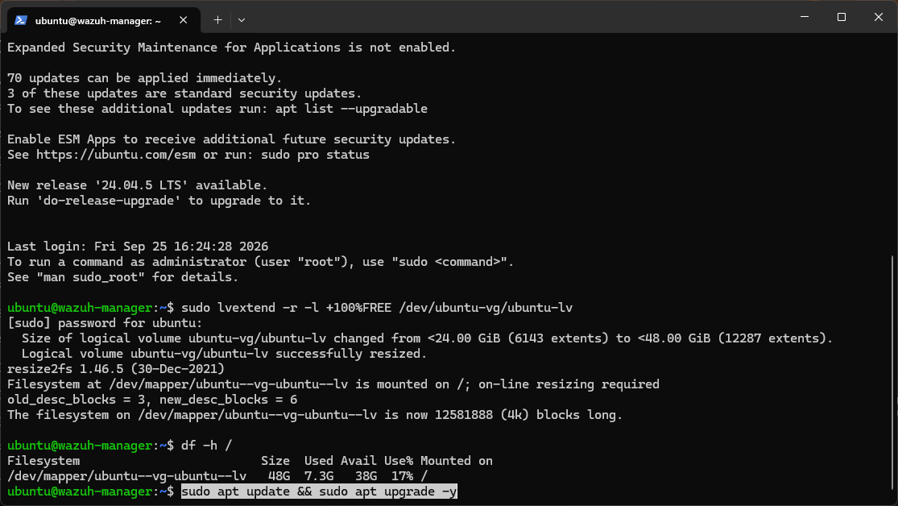
- Install the Wazuh manager:
First I run the GPC key it will not produce any output following is the key details:
This key lets your system cryptographically verify that any Wazuh package you install later actually came from Wazuh and wasn't tampered with in transit. It's the same trust mechanism behind every Linux package manager, without it, apt would refuse to install Wazuh's repo packages. This step doesn't install anything itself, it just sets up trust.

Run the Wazuh installer:
curl -sO https://packages.wazuh.com/4.12/wazuh-install.sh && sudo bash ./wazuh-install.sh -a
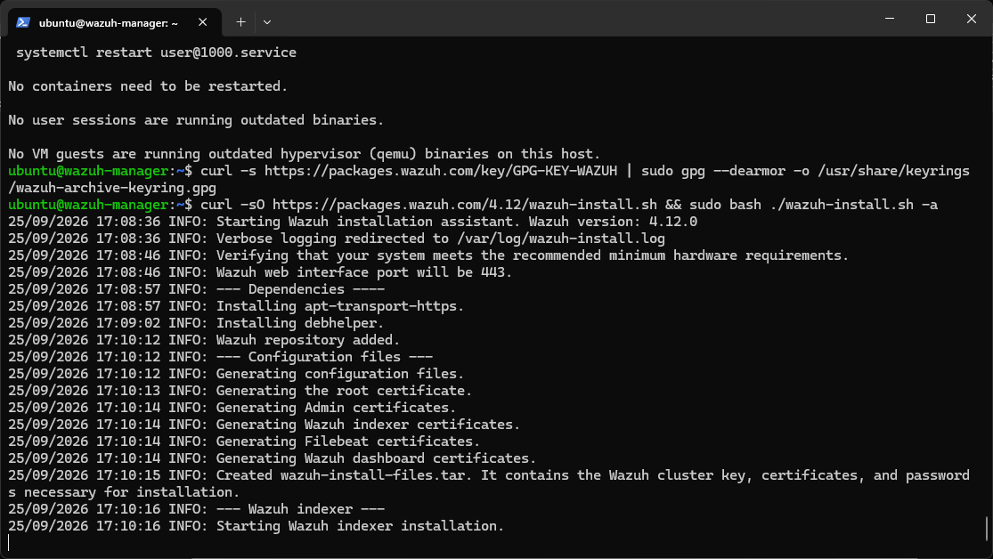
Figure 7 installing the wazuh
During installation I faced an error the installation of wazuh failed in this situation first I checked the reason of the error and for that I used the following command:
sudo tail -n 50 /var/log/wazuh-install.log

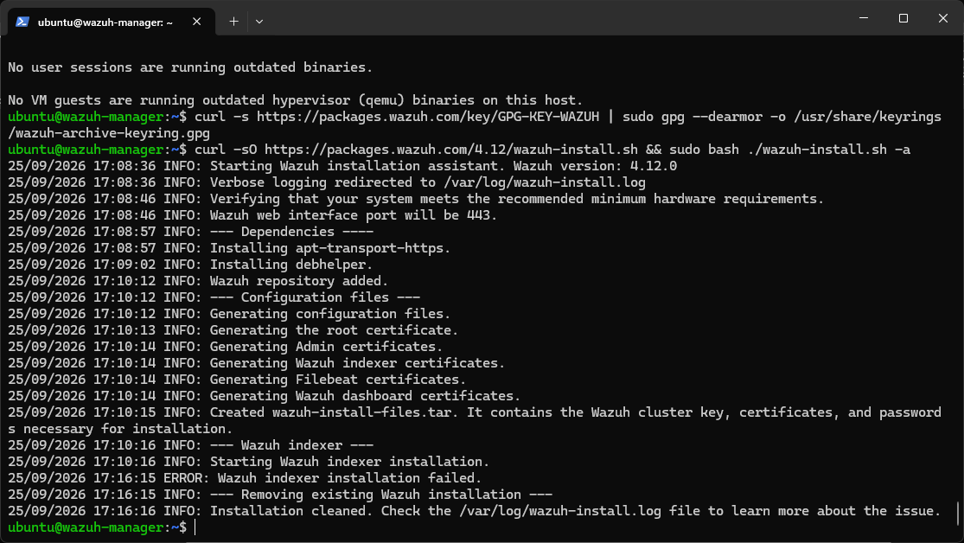
Figure 8 error message
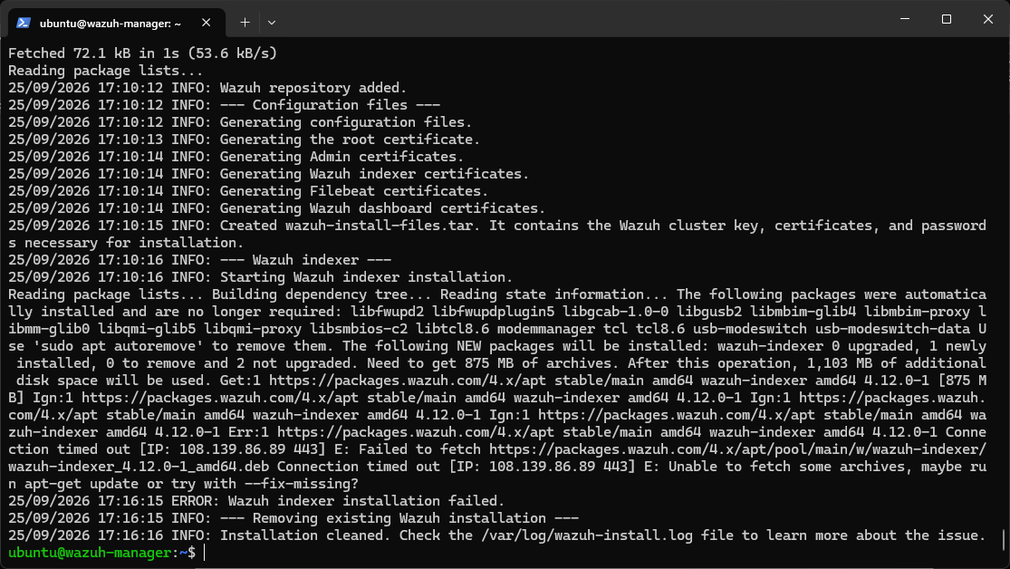
The reason for error was a network/download timeout my VM tried to download the 875MB wazuh-indexer package but the connection dropped or was too slow/unstable partway through. This is common on home Wi-Fi or with a flaky NAT connection, not something wrong with my setup.
So I simply retyped the command to install the wazuh.
After retyping the command my wazuh installation completed without any issue.
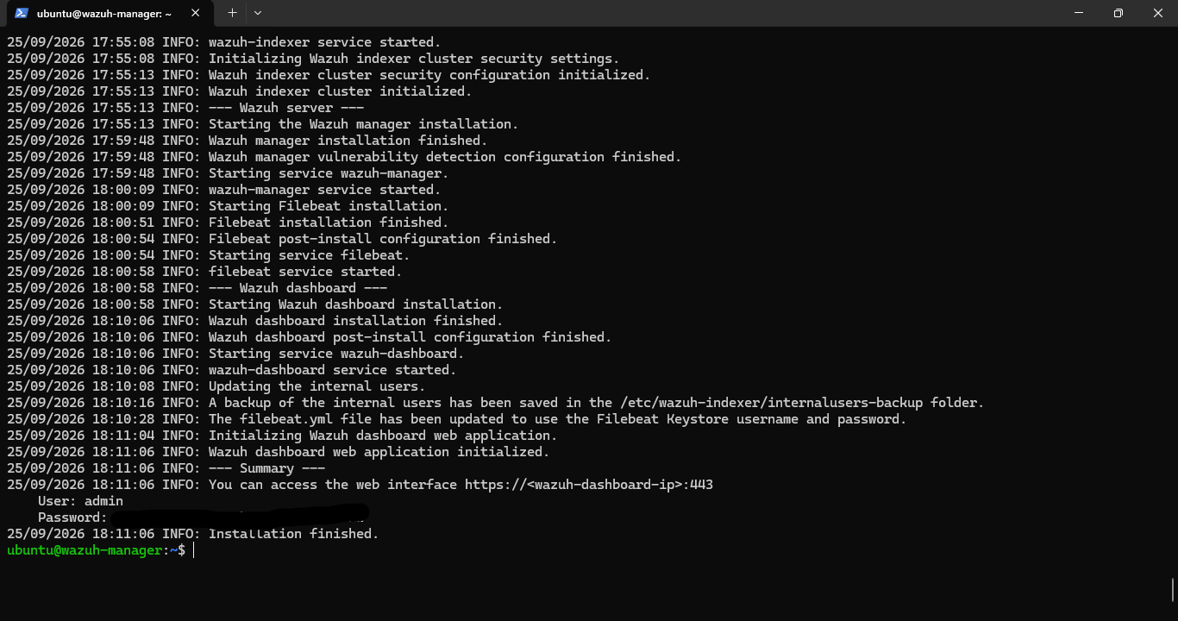
Figure 9 wazuh successfully created
- Access the Wazuh Dashboard:
To access the dashboard of wazuh I used my windows 11 host browser and type https://192.168.26.129
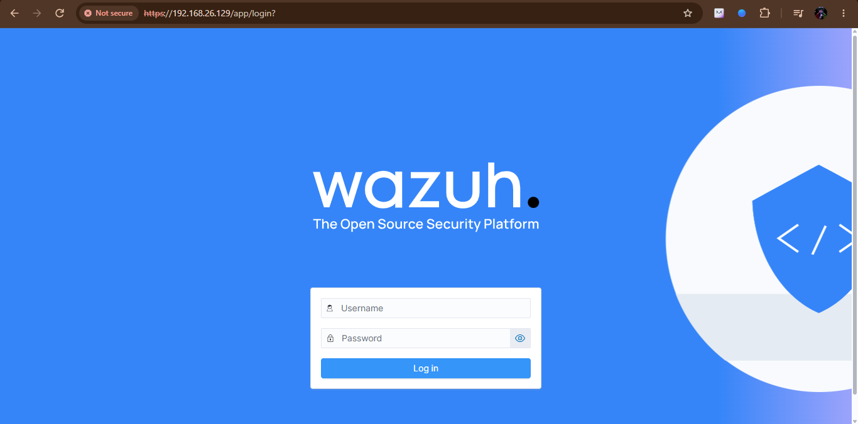
Figure 10 Wazuh Dashboard
I typed the username and password here which I got during the installation of wazuh. After entering the username and password I saw the dashboard for wazuh:
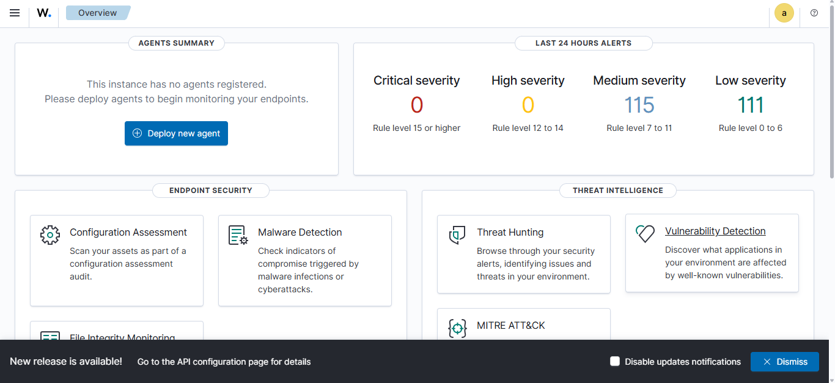
- Installing the Wazuh Agent on Windows 11:
To download the agent MSI type:
https://packages.wazuh.com/4.x/windows/wazuh-agent-4.12.0-1.msi
in the browser of window 11 and then the .msi file will be downloaded itself after downloading it install it by following steps:
- Run the downloaded .msi file.
- Accept the license terms.
- Use default settings/install location throughout.
- Important: when it reaches the configuration screen asking for the manager IP, you can either:
  - Fill it in now (192.168.26.129), or
  - Leave it blank and configure it after install via the Wazuh Agent Manager GUI (easier if you want to double check the IP first)
- Finish the installation.

- Registering the Agent with the Manager. 🔗:
Step 1: Generate the agent key on Ubuntu (manager side)
To register the agent I generated the agent key on ubuntu for this I typed the following command in the ssh session of the ubuntu vm:
sudo /var/ossec/bin/manage_agents
After this command I saw an interface I followed the following steps to get the ID and key for your agent:
- Press A (Add an agent)
- Agent name: type something like Win11-Host and press Enter
- Agent IP address: type any and press Enter (since your Windows host's IP could change with DHCP)
- It'll show a summary and ask to confirm — press Y
- It'll assign an Agent ID, usually 001 since this is your first agent
- Now press E (Extract key)
- Enter the Agent ID (001)
- It'll print a long encoded key string — copy this whole string carefully (triple-click or select from start to end)
- Press Q to quit the menu
Step 2: Apply the key on Windows (agent side)
I Opened the wazuh agent on windows then I saw an interface like that enter the ip address and key you got while creating the agent
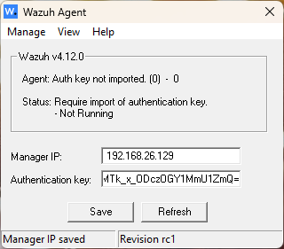
Figure 11 wazuh agent
After conforming that the authentication key is imported I followed the following steps to start the wazuh agent
- Click Manage (top menu)
- Click Start
- Then click Refresh
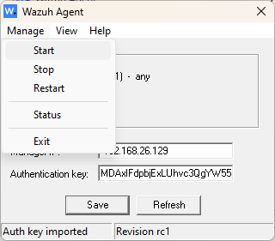
Dashboard of WAZUH
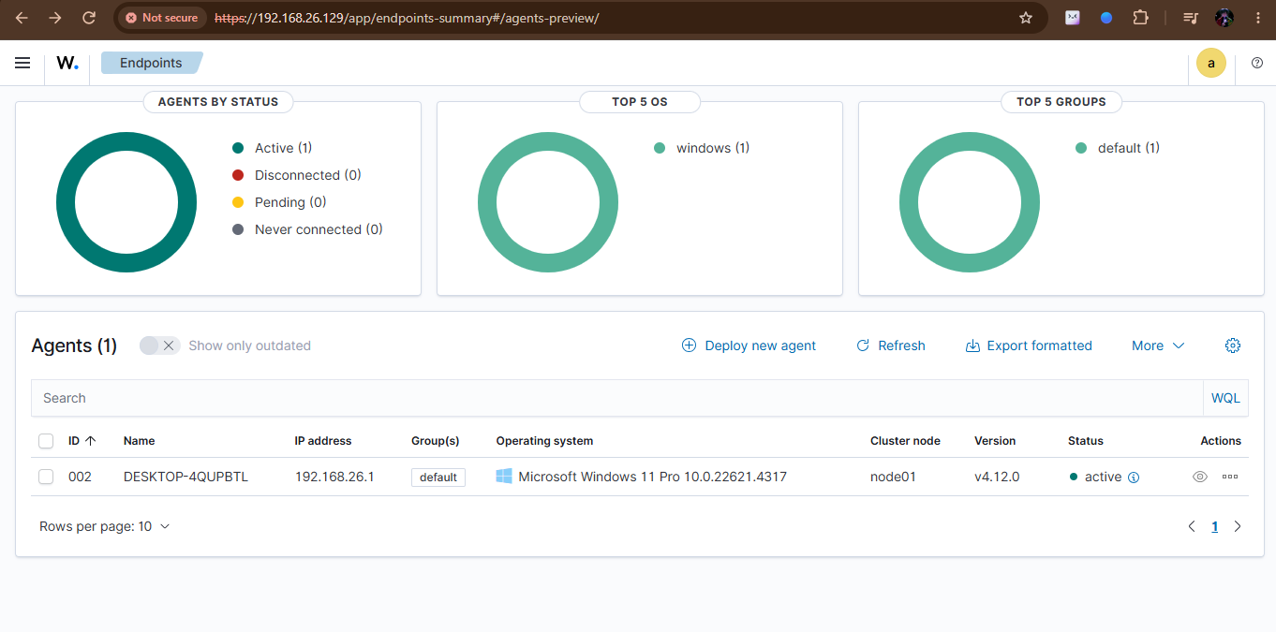
Figure 12 Dashboard of wazuh showing the agent
- File Integrity Monitoring (FIM):

Step 1: Create a test folder:
- Open File Explorer
- Go to C:\
- Right-click → New → Folder
- Name it: Wazuh-Test
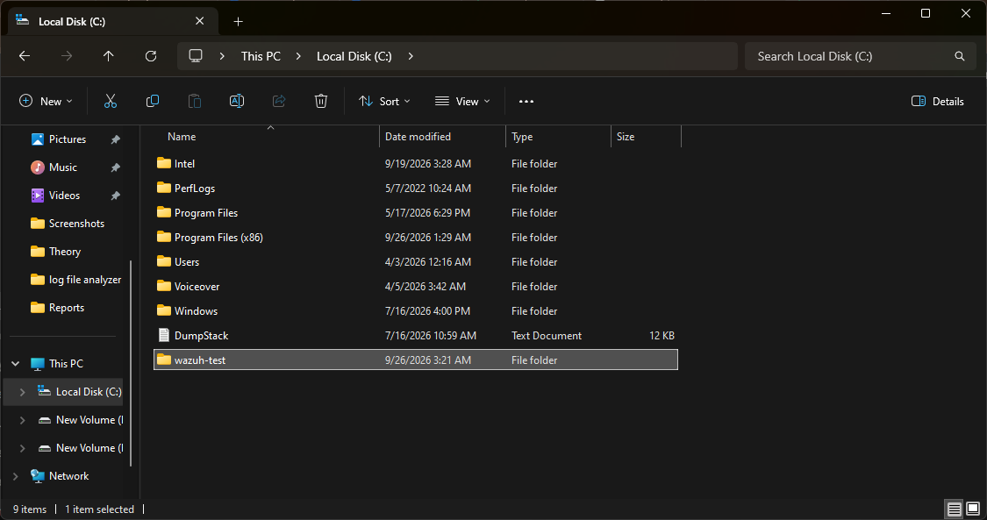
Step 2: Edit the agent config:
- Press Windows key, type Notepad, right-click → Run as administrator → Yes
- Inside Notepad: File → Open
- Navigate to:
C:\Program Files (x86)\ossec-agent
- Change the file filter (bottom-right dropdown) from "Text Documents" to "All Files"
- Open ossec.conf

It looked like that after I opened the ossec.conf file
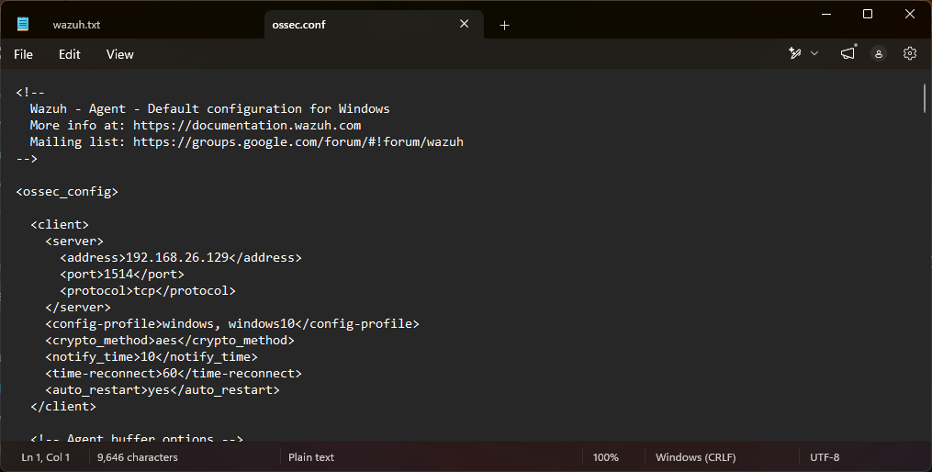
Figure 13 ossec.conf file
Step 3: Find the FIM section
Use Ctrl+F to search for:
<syscheck>
I saw a block that looked something like that:
xml
<syscheck>
<disabled>no</disabled>
...
<directories>C:\Users, C:\Program Files\...</directories>
...
</syscheck>
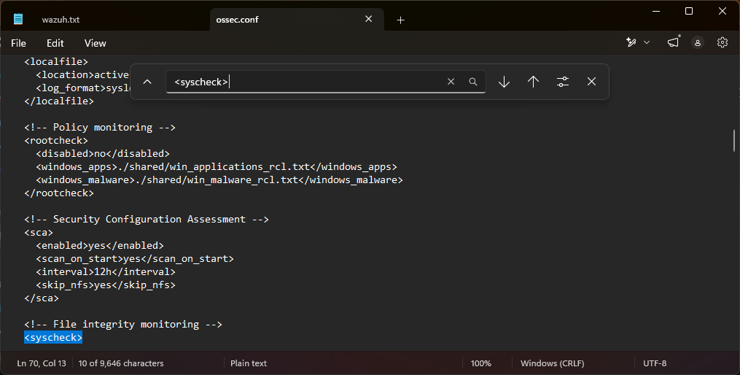
Step 4: Add your monitored folder
Right before the closing </syscheck> tag, add this new line:
xml
<directories realtime="yes">C:\Wazuh-Test</directories>
This tells the agent: "watch this folder in real-time, and report any file created, modified, or deleted here."
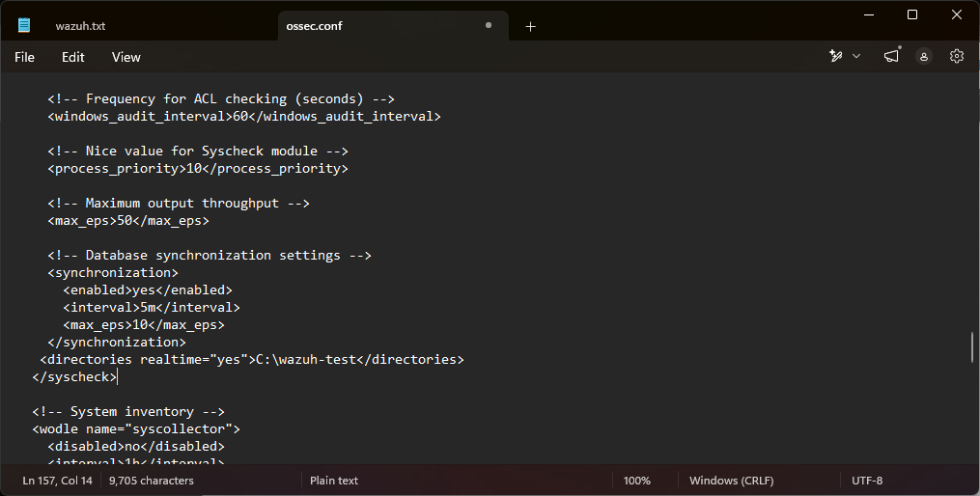

Step 5: Save
Then:
- Ctrl+S to save
- Close Notepad

Now restart the agent
Open Wazuh Agent Manager again then follow the following steps:
- Manage → Restart
- Click Refresh — status should show Running
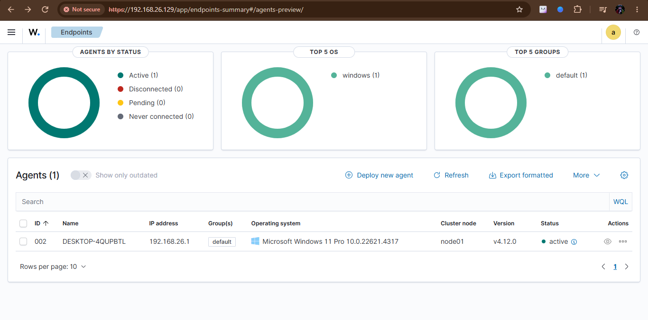
Figure 14 agent is active
- Test & Verify:

Step 1: Open the dashboard's FIM view
I Clicked the top-left icon and then click on the Endpoint security under it then I saw the file integrity monitoring
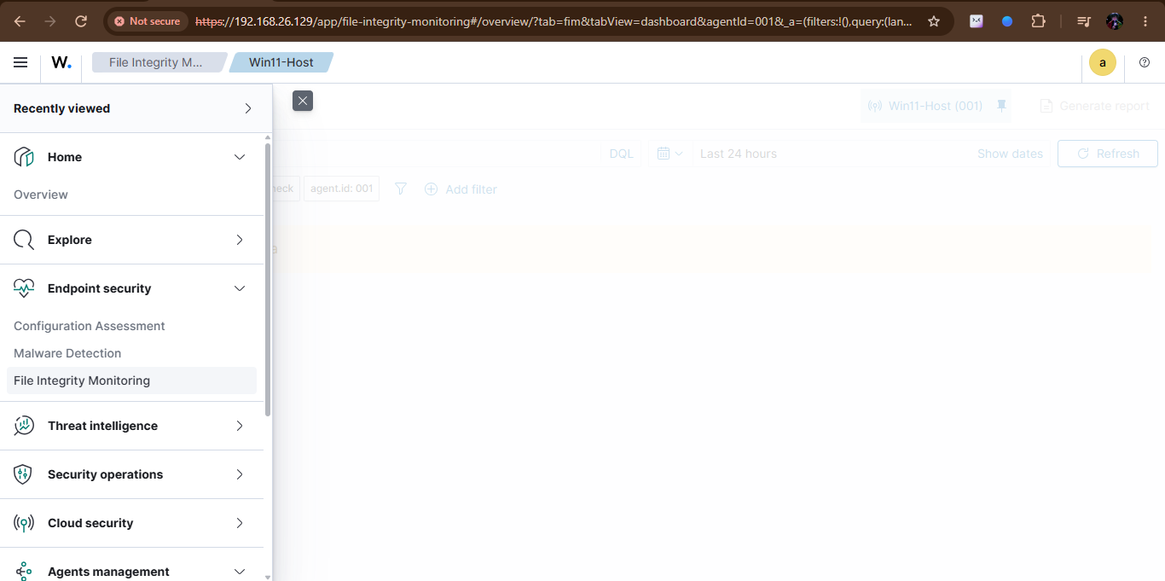
I Clicked on the file integrity monitoring then I saw the following interface right now it would be empty because there wasn’t any activity.
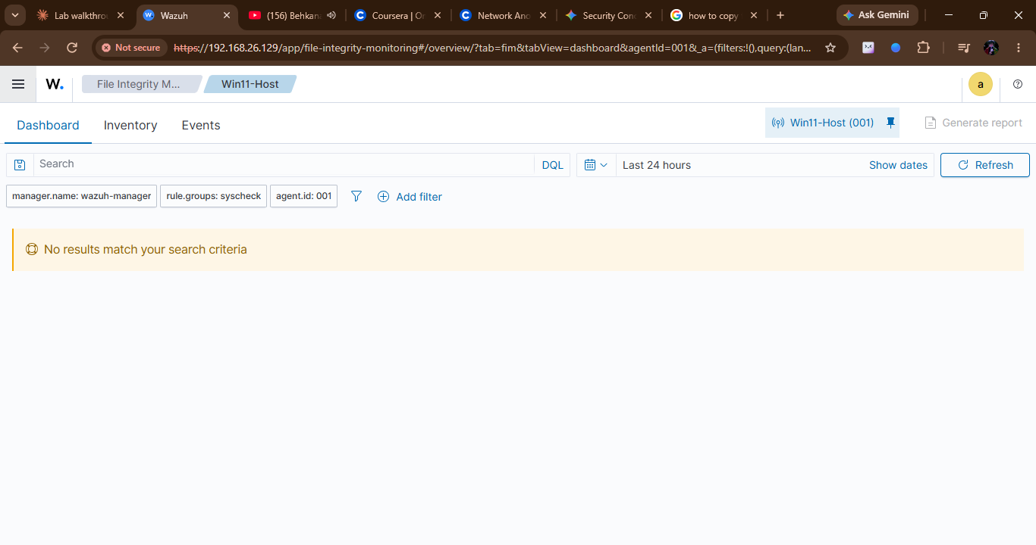
Figure 15 dashboard to show the events of agent
Step 2: Create a file (triggers "added")
- Open C:\Wazuh-Test in File Explorer
- Right-click → New → Text Document
- Name it test1.txt
Waited for 20 to 30 sec and then refreshed the dashboard’s integrity Monitoring page.
In the events dashboard you can see the added event at the bottom of the dashboard
The Added event (rule 554) confirms Wazuh's real-time syscheck detected the new file within seconds of creation, demonstrating the agent's monitoring is functioning as configured
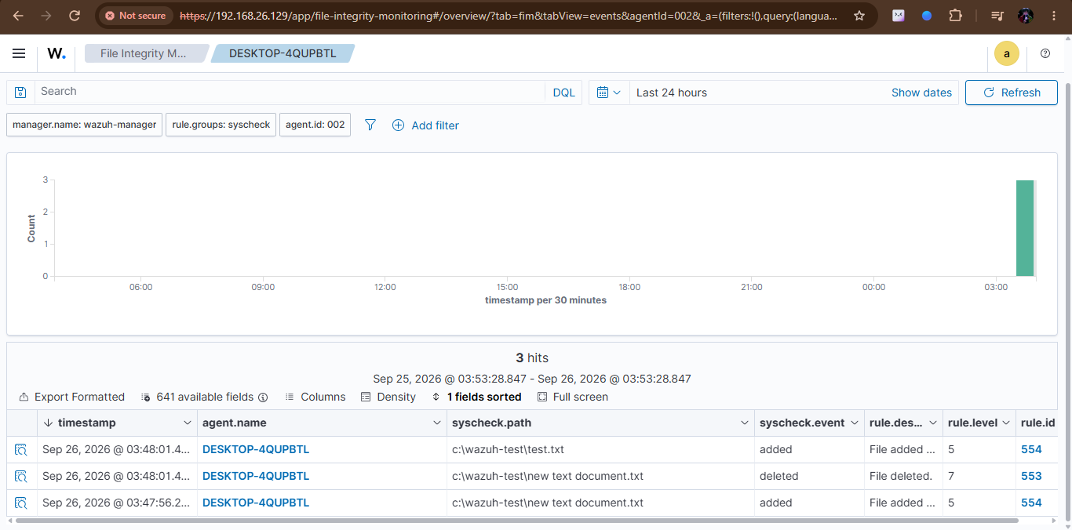
Figure 16 added event
Step 3: Modify the file (triggers "modified")
- Open test1.txt
- Type something inside it, e.g. hello wazuh
- Save (Ctrl+S)
After making some changes to the file I refreshed the dashboard and you can see the modified event in the logs of events
As you can see in the screen shot there is an event name modified
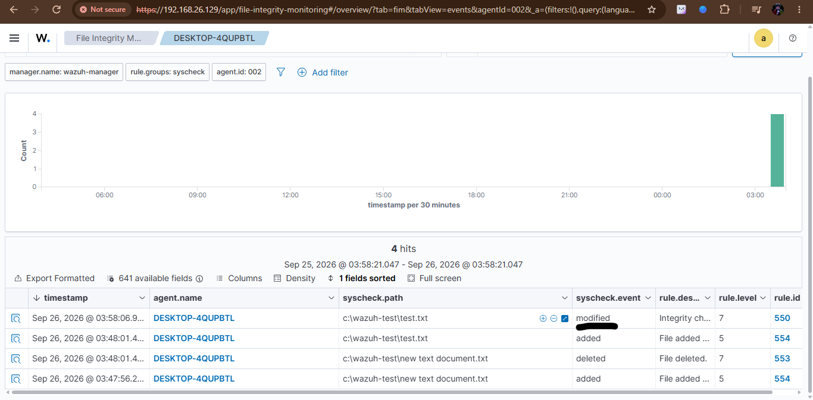
Figure 17 modified event
Step 4: Delete the file (triggers "deleted")
As you can see in screen shot there is an event name deleted
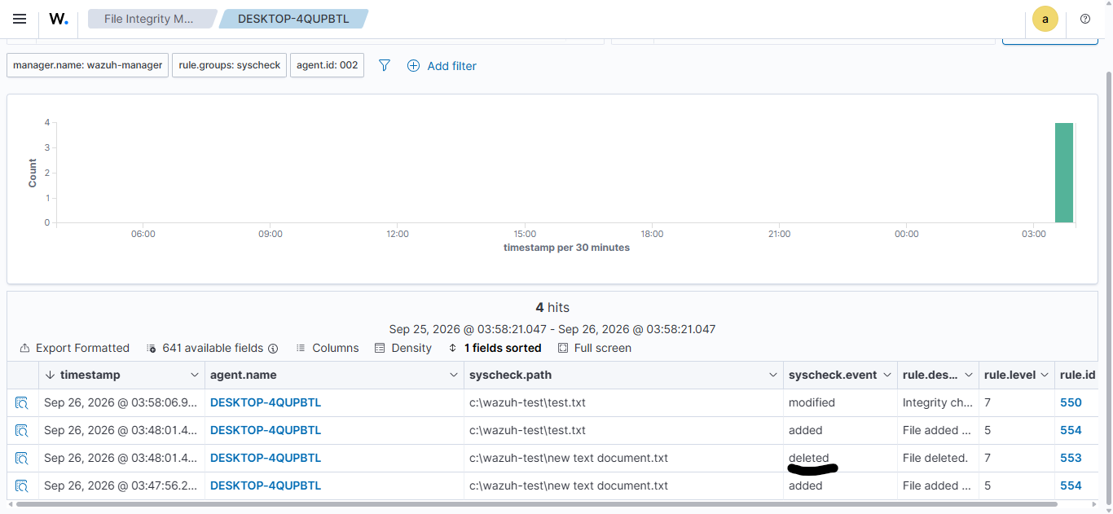
Figure 18 Deleted event
Step 5: Inspect an event
Click into any one of these events in the dashboard. Look for:
- File path
- Timestamp
- Agent name/ID
- Checksums (MD5/SHA1/SHA256, before/after for modifications)
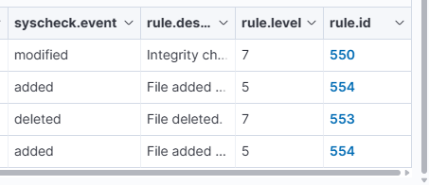
Summary
This lab demonstrated building a functional Security Information and Event Management (SIEM) and File Integrity Monitoring (FIM) solution using Wazuh, in a home lab environment consisting of an Ubuntu Server VM (Wazuh manager, indexer, and dashboard) and a Windows 11 host (Wazuh agent).
Key outcomes:
- Deployed a full Wazuh stack (indexer, server, dashboard) on a dedicated Ubuntu VM
- Registered and connected a Windows agent to the manager, verified via the Agents dashboard
- Configured real-time File Integrity Monitoring on a test directory
- Generated and verified FIM events (file creation, modification, and deletion), each mapped to their respective Wazuh rule IDs (554, 550, 553)
- Practiced core SOC analyst workflows: interpreting raw event data, verifying agent connectivity, and troubleshooting configuration issues (e.g. resolving a malformed IP address caused by a stray whitespace character in the manager configuration)
This lab reinforced practical skills directly relevant to SOC Level 1 work: endpoint monitoring, log analysis, and the operational reality that security tooling requires careful configuration and troubleshooting, not just installation. In a production environment, FIM scope would be narrowed to high-value targets (e.g. system configuration files, application directories) rather than broad monitoring, to reduce alert noise and focus analyst attention on meaningful changes.

